Creating a New User

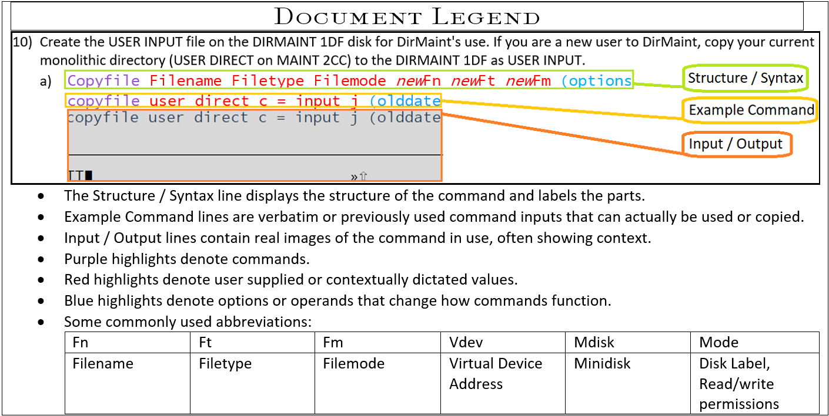

1. Request a copy of the disk map to identify GAP’s in available storage via :
   1. Dirm Dirmap  
        
      
   2. Obtain the Directory map file via :
      1. Receive spoolid (rep  
         Receive 41 (replace  
         
         1. Rep option replaces any current same name file
   3. Identify the region used for user storage (typically rows of Name 191) and find a gap of 100 or more taking note of the cylinder the starts the gap:  
      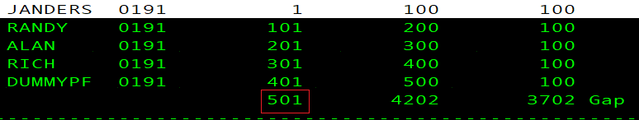
      1. The gap-start cylinder will be the number used to edit the MDISK statement for the new user’s (In this example the gap begins on 501)
2. Acquire copy of USER Direct CMS file to act as template.
   1. Dirm for user get  
      
      1. Should the file be locked already submit an unlock then repeat step 2)a)  
         Dirm for user unlock  
         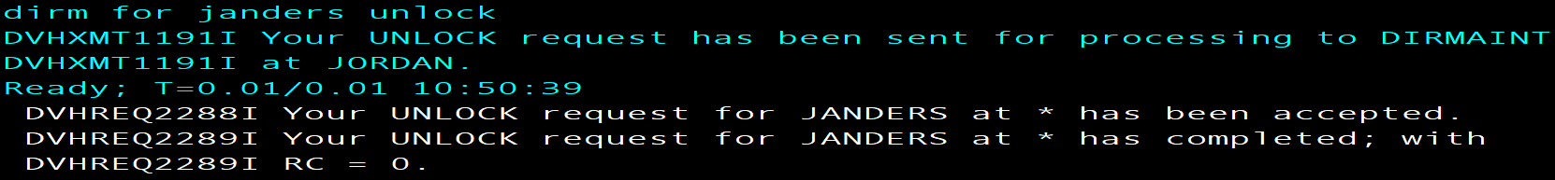
   2. Obtain the Direct file via :
      1. Receive spoolid (rep  
         
         1. Rep option replaces any current same name file
3. Xedit the Direct file to match the new user’s desired login, storage, and access information
   1. Xedit fn ft fm  
      xedit dummypf direct a  
        
      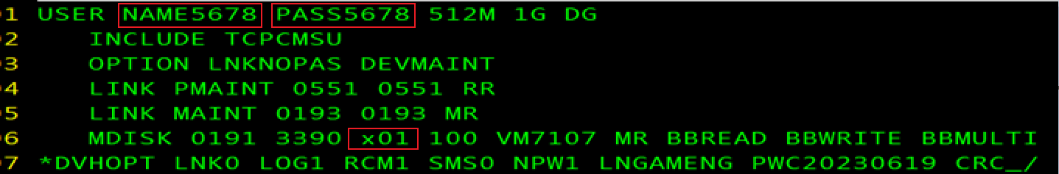
      * 1. Edit username and password
        2. Include TCPCMSU (this profile contains shared links and basic console statements)
        3. Nopass Option for utility drives (ex. MAINT/DEVMAINT/PMAINT)
        4. Link and MDISK statements to access tools and your personal storage (191 A)
           1. Be sure to write the correct starting cylinder((x01 in red box above) Step 1-c’s image shows the example gap in red box)
        5. POSIXINFO UID and GID if intended to use BFS
   2. Type FILE in the command line to save the file.
4. Put on Judas Priest's Screaming For Vengeance.
   1. Turn it up to 11.  
      
5. Request, acquire and update the authfor control file. (This enables commands, do so only for known admins.)
   1. Dirm send authfor control  
      
      1. Add copies of the 150 and 140A lines for User – Matching others in file
   2. Receive spoolid option  
      Receive 105 (replace  
      
   3. Dirm file authfor control  
      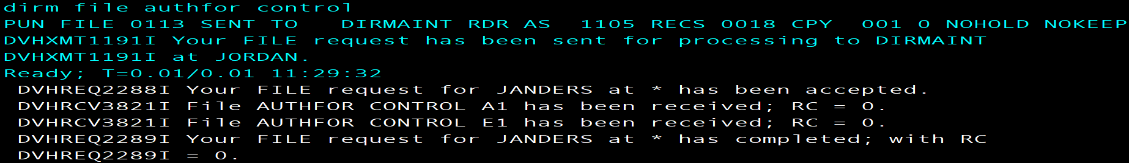
      1. This submits changes made to the Authfor file
6. Add the user’s name to the system :
   1. Dirm add user  
      DIRM add Rich  
      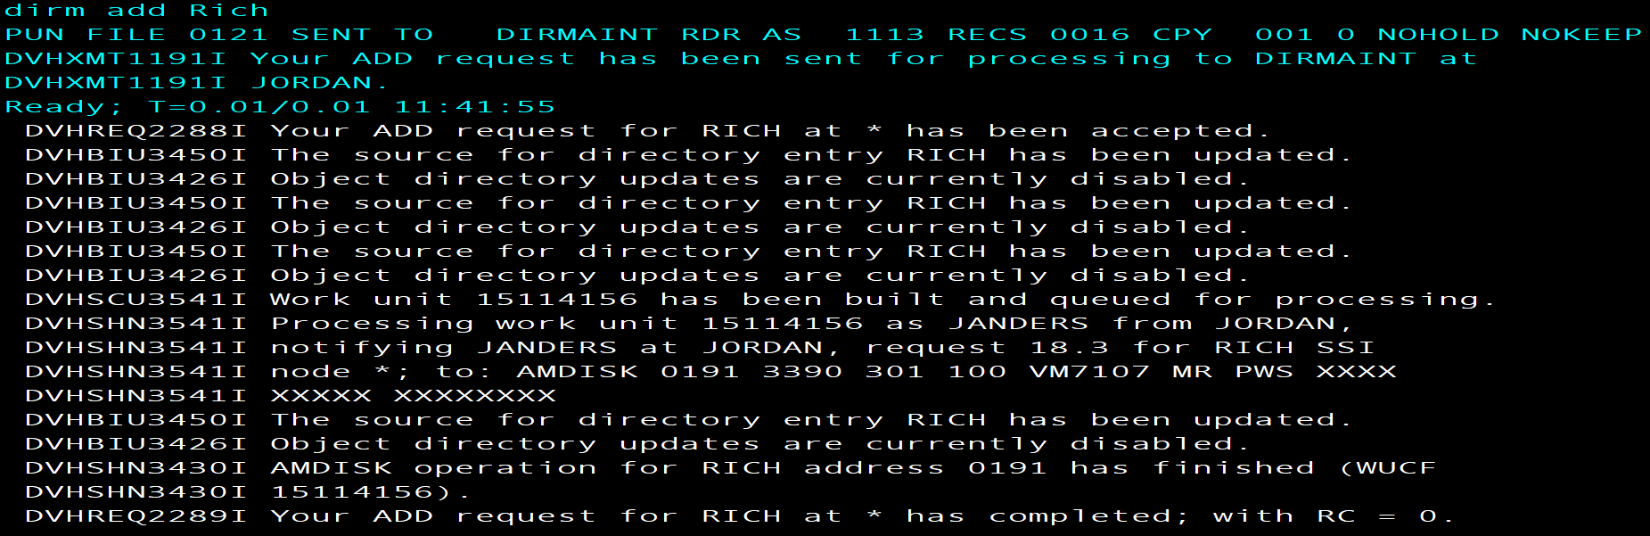
7. Check the newest USER MDISKMAP to make sure there are no Overlaps.
   1. Use the slash character and user name to Xedit search the DISKMAP:
      1. /username
8. Logon to the new user and FORMAT 191 A
   1. FORMAT vdev filemode  
      FORMAT 191 A  
      
      1. Answer 1 for Yes  
         
      2. Give minidisk unique name (typically three letters three numbers)  
         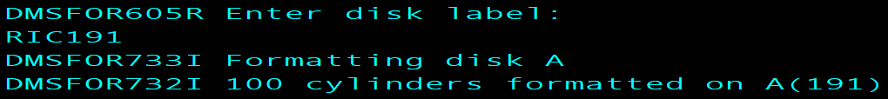
9. VMLINK to another user to get the needed setup/reference files:
   1. Vmlink user 191  
      VMLINK Rich 191  
      
      1. profile exec
      2. syn synonym
      3. profile xedit  
         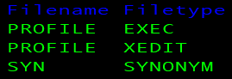
   2. Acquire the files using copyfile or sendfile them from another user to new user
      1. Copyfile fn ft fm Newfn Newft Newfm  
           
         or
      2. Sendfile fn ft fm to user
   3. Pull down the copies
      1. Receive spoolid (options  
         
10. If any additional changes were made after, “DIRM add name” (step 6-a) send the new Direct file to DIRMAINT (Or update the directory/bring changes online)
    1. DIRM for user options  
       Dirm for Janders replace   
       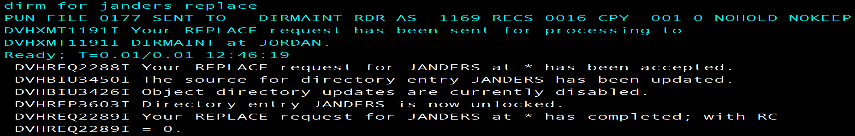
       1. If the file is unlocked and requires a lock for replacement input the following and repeat 10-a.
          1. Dirm for user options  
             DIRM for Janders lock  
             